CHAPTER 8: Forces, energy and motion
Worksheet 8.3

Acceleration
Science Quest 10: pages 311–12
Answers
The velocities of two objects were recorded over ten second time periods, as shown in the examples below.

Example: Gaining and losing speed
Time (s) | 0 | 1 | 2 | 3 | 4 | 5 | 6 | 7 | 8 | 9 | 10
Velocity  (m/s) | 0 | 2 | 4 | 6 | 8 | 10 | 12 | 11 | 10 | 9 | 8
1. (a) Use a spreadsheet application such as Excel to plot a line graph of this data.
(b) Format your graph. Ensure that the graph has a title and that each axis has a title and appropriate units. Print a copy of this graph and attach it to this worksheet.
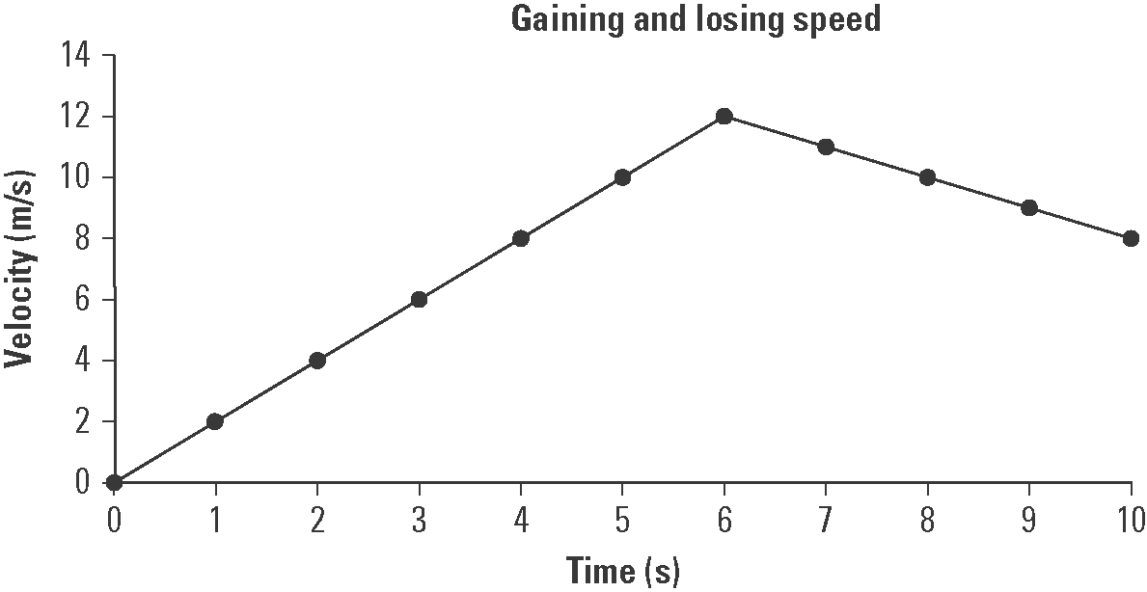
Use the printed graph to answer the following questions.
(c) Explain the shape of the graph.
The object accelerates uniformly for the first six seconds and then decelerates uniformly for the next four seconds.

(d) At the eight second mark the object’s speed begins to decrease. If the object’s speed continues to decline at the same rate after ten seconds, at what time will its velocity be zero?
At t = 18 seconds its velocity will be zero as its velocity is decreasing by 1 m/s every second.

Example: Falling down
Time (s) | 0 | 1 | 2 | 3 | 4 | 5 | 6 | 7 | 8 | 9 | 10
Velocity  (m/s) | 0 | 9.8 | 19.6 | 29.4 | 39.2 | 49.0 | 58.8 | 68.6 | 78.4 | 88.2 | 98.0
2. (a) Examine the data table and determine the pattern in the data. Use this pattern to complete the table.
(b) Use a spreadsheet application such as Excel to plot a line graph of this data.
(c) Format your graph. Ensure that the graph has a title and that each axis has a title and appropriate units. Print a copy of this graph and attach it to this worksheet.
CHAPTER 8: Forces, energy and motion
Worksheet 8.3

Page 2

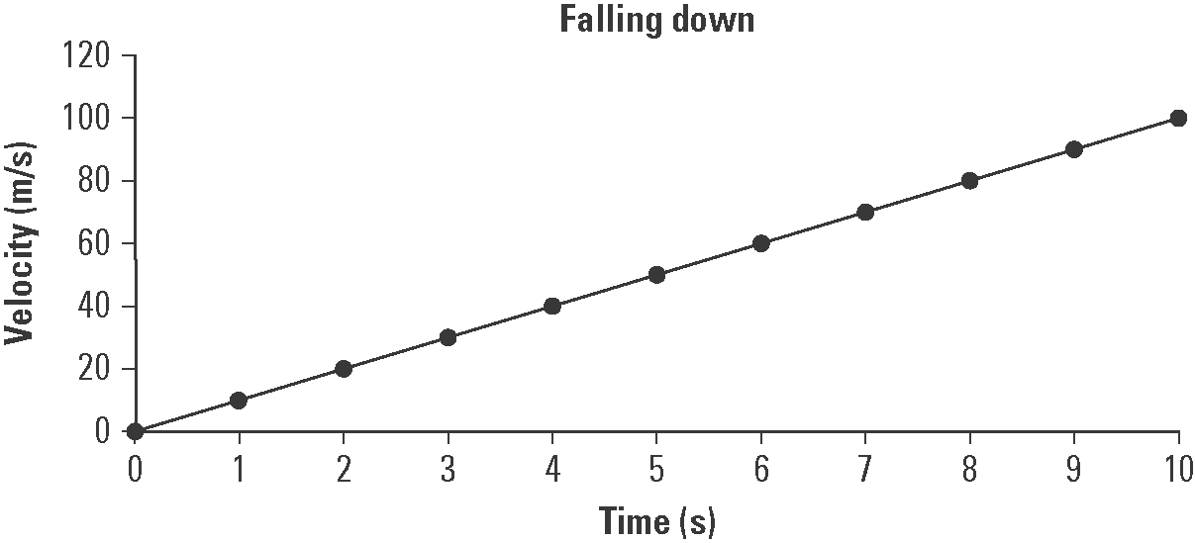
Use the printed graph to answer the following questions.
(d) Explain how this graph shows that falling due to gravity is an example of uniform acceleration.
The graph is linear with a constant slope. Thus its velocity is increasing at a uniform rate as would be expected for a body falling in a gravity field (as long as friction is absent or negligible).

(e) The slope of the graph is equal to the acceleration due to gravity. Determine the slope of the graph in m/s².
Slope = 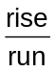 = 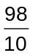 = 9.8 m/s²

